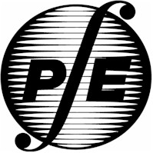

# **Idaho Society of Professional Engineers**

2015 ISPE Annual Meeting

“Professional Engineers –

Protecting the Public,

Enhancing the Profession,

Pioneering the Future”

#### June 10 - 12, 2015

*The Coeur d'Alene Inn*

*506 West Appleway Avenue*

*Coeur d'Alene, ID 83814*

# **Sponsors**

The Idaho Society of Professional Engineers gratefully appreciates support from the following Sponsors:

**Breakfast Sponsor**



**Platinum Sponsor**

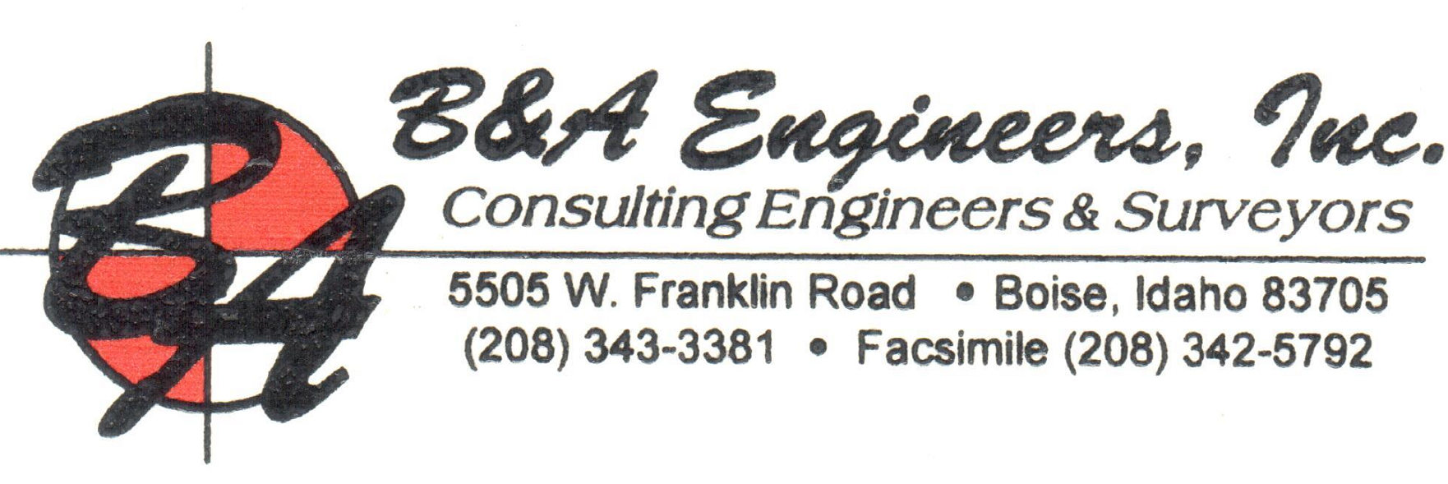

**Break Sponsor**

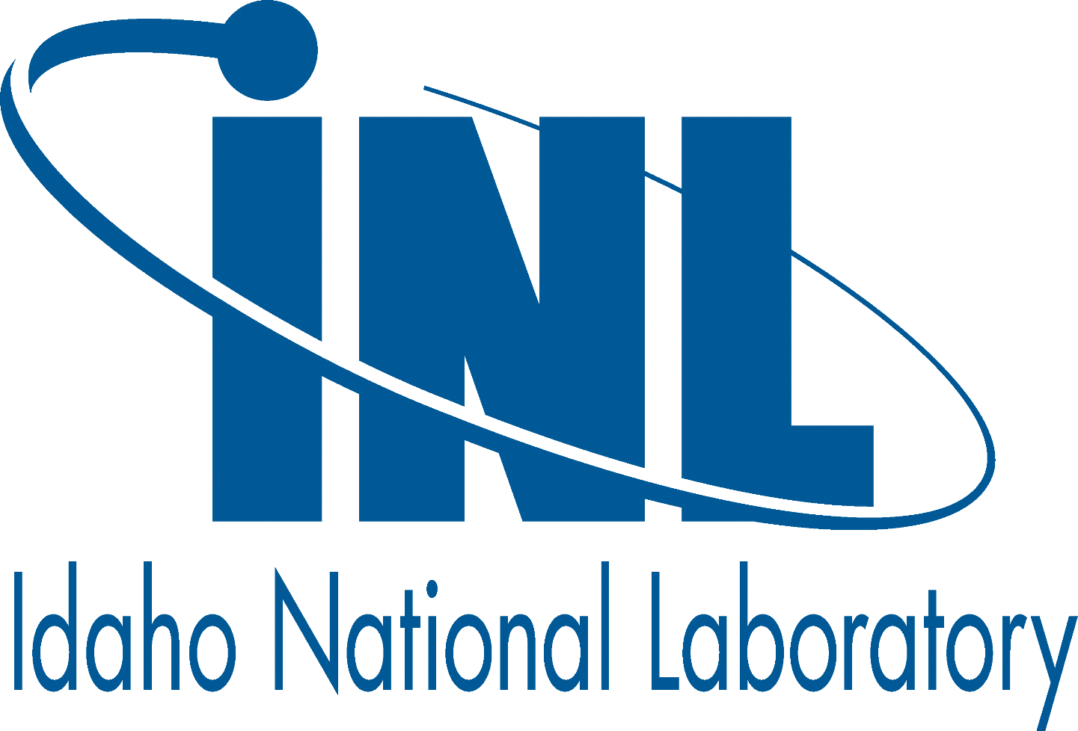

**Silver Sponsors**



**HDR Engineering Inc**



**ISPE 2015 Annual Meeting**

**Wednesday, June 10**

**12:00 – 2:00 PM ISPE State Board Meeting**

**Syringa Room**

**1:00 – 5:00 PM ISPE Golf Tournament**

**Prairie Golf Course**

***Evening Social/BBQ is included with Golf Tournament Registrations.***

The BBQ is also available to non-golfers wishing to attend the Social

**5:00 – 8:00 PM Evening Social/Networking**

**Prairie Golf Course**

All Annual Meeting attendees are encouraged to attend the Evening Social.  ***If you registered for the ISPE Golf Tournament the Evening Social/BBQ is included with your registration.***

**Thursday, June 11**

**7:00 – 8:30 AM**  **Breakfast**

**Cataldo Room Welcome/ISPE Membership Meeting**

**9:00 – 10:20 AM** **Idaho Board of Professional Engineers and Professional**

**Sherman Room Land Surveyors – Update on Issues (1.5 PDH)**

**Keith Simila, PE,**

**Executive Director to the Idaho Board of Professional Engineers and**

**Professional Land Surveyors**

Keith will update engineers on the new laws and rules and anticipated laws and rules that will impact professional engineers. New provisions such as board expansion, increasing late fees, qualifications based selection requirements, examination changes, and a new section that allows a “fine in lieu of discipline” are enacted and will be implemented this year. The board will start rule making and stakeholder input related to faculty licensure, conflicts of interest changes, retired and expired engineer status and license reinstatement rules for retired or expired licensees. Charts that display trend data related engineering licensure will be shared. Case studies on disciplinary actions and complaints will help engineers avoid violating the ethics rules of the board and will be discussed with attendees in open dialog.

**10:30 – 11:50 AM NSPE and the Power of Persuasion (1.5 PDH)**

**Sherman Room Julia H. Harrod, PE, F.NSPE**

**NSPE Treasurer**

Learn how to apply the science of persuasion to influence the outcomes important to you. We will explore how NSPE members in particular can use 6 simple “persuasion principles” to impact legislation, win clients, and influence organizations. Julia Harrod, PE will present an interactive, discussion-oriented

session using concepts from “Harnessing the Science of Persuasion” by Robert Cialdini while providing an update on current NSPE activities.

**12:00 – 1:50 PM** **Lunch**

**Cataldo Room Forensic Engineering (1.5 PDH)**

**Keynote Speaker: Jerry Ogden, MS, PE, OEC Forensics and representing NAFE**

The field of Forensic Engineering is a fascinating and unique application of engineering principles. The term “forensic” simply means “for the courtroom”, indicating the Forensic Engineer applies their education, training and experience to assist in the resolution of legal problems or issues. This presentation will explore the wide diversity of Forensic Engineering applications, and generally discuss how education, training, experience and professional licensure play a key role in determining the qualifications of the engineer for expert testimony. Examples regarding engineering ethics will be presented, to include a potential industry wide property damage assessment cover-up resulting from Hurricane Sandy that hit the Atlantic Coast in 2012.

**2:00 – 2:50 PM Legal Liability –**

**Sherman Room “The Good, The Bad, and The Ugly” (1 PDH)**

**Christine Drage Esq.**

Are your engineering and construction contracts ready for the court system of 2015 and beyond? The courts have been all over the place in decisions lately, and so it is essential every design professional know about the good, the bad and the ugly contract clauses that didn’t used to, but now impact every construction project and every design professional business.  Ms. Drage has been representing design professionals for over 21 years in contract formation, project disputes and litigation.  She will offer real  life examples of how courts treat design professionals and the contracts they sign, and what you can do to minimize your exposure to liability and lawsuits on your projects.

**3:00- 3:50 PM Lardo Bridge Replacement (1 PDH)**

**Sherman Room Lewis Venard, PE**

**HW Lochner**

The Lardo Bridge replacement in the resort town of McCall, Idaho is the first implementation of slide-in-bridge-construction (SIBC) technology of a permanent structure by Idaho Transportation Department (ITD). The new single-span 155-foot precast concrete girder bridge replaces an existing 5-span bridge carrying SH-55 over the outlet of Payette Lake.

McCall’s tourist season extends from Memorial Day through Labor Day and picks up again in late fall for snowmobilers. With SH-55 as the main route along the lake, ITD wanted to minimize delays on SH-55, and decided to let this project as a design-build and used A + B bidding to encourage the design-build teams to minimize construction durations.

**4:00 – 4:50 PM** **Ethics Case Studies –**

**Sherman Room “What Would You Do?” (1 PDH)**

**Moderator – Eric Olson, PE**

Have you ever wondered whether something that you were about to do was ethical or appropriate? As a member of the National Society of Professional Engineers, you have a resource many engineers do not have, and wish they did. In this hard-hitting seminar, the attendees will review a series of actual ethics cases that land very close to home for most practicing professional engineers. These are cases that were brought before the NSPE Board of Ethical Review, with the names and details changed to protect privacy. The audience is invited to participate by discussing the issues, and then asked to propose hypothetical recommendations to the Board of Ethical Review. After this, the actual ruling of the Board is disclosed, and discussed. This has frequently been both a lively, as well as enlightening seminar, and is always intensely thought-provoking. Many attendees have come away with a much greater appreciation for the value benefit that the Board of Ethical Review represents to members, and a heightened awareness for how easy it can be to make poor choices in this arena, if a person lacks access to resources that could help.

**5:00 – 6:00 PM Social**

**Cataldo Room**

**6:00 – 8:00 PM Banquet Dinner, Awards, and**

**Cataldo Room Officer Installation**

**Friday, June 12**

**7:15 – 7:50 AM**  **Breakfast**

**Sherman Room**

**8:00 – 8:50 AMCurrent State of Remotely Piloted Aircraft**

**Sherman Room (1 PDH)**

**Brad Ward**

**VP of ADAVSO, Pres. of Empire Unmanned**

Remotely Piloted Aircraft, commonly referred to as drones, are a growing industry with significant potential. They are facing both public privacy concerns and an evolving regulatory environment. Learn about the current state of this exciting technology along with the challenges involved in pioneering its use into commercial applications. ADAVSO was one of the first companies in the United States to receive a commercial exemption approved by the FAA to operate commercial Unmanned Aircraft Systems specifically designed for precision agriculture.

**9:00 – 9:50 PM Idaho National Laboratory (INL) (1 PDH)**

**Sherman Room Dr. Todd Allen**

**Deputy Laboratory Director for Science and**

**Technology**

The Idaho National Laboratory is the U.S. leading laboratory for nuclear energy research as well as a primary energy systems demonstration facility across most energy technologies. INL holds a unique combination of facilities and capability in the area of nuclear fuels, with the ability to design, fabricate, irradiate, characterize and model nuclear fuels. This capability is applied to understanding the performance of current light water reactor fuel, the performance of used fuel in storage and the performance of novel new fuels for advanced systems and advanced fuel cycles. This presentation will provide an overview of the INL and its capability in analyzing nuclear fuels, a description of why each fuel is unique, research needs associated with research quantities of used light water reactor fuel, and the barriers between the research fuel and the Snake River Plain aquifer.

**10:00 – 10:50 AM** **4D & 5D BIM Technology; HDR Case Studies:**

**Sherman Room Bridges, Airports, and Traffic Management**

**(1 PDH)**

**Rick Lovel**

**Professional Associate, Visualization Manager**

4D simulations are a tool for visualizing inherently abstract and complex temporal scheduling data which is otherwise buried in deeply nested Gantt charts. Today’s 4D simulation software generates virtual rehearsals which intuitively illustrate processes along the timeline. By linking objects of a three dimensional model to the tasks in actual project schedule, it helps to reduce major scheduling errors just by inspection and improves communication within the project team. 4D simulation is not "just for construction contractors" as illustrated by HDR's deployment with clients MnDOT (St. Croix Bridge) Iowa DOT (Council Bluffs Interchange System) and Ft. Lauderdale Airport.

**11:00 – 11:50 AM** **Coeur d’ Alene Vision 2030 (1 PDH)**

**Sherman Room** **Charles Buck**

**Associate Vice President and Center Executive Officer, University of Idaho - Northern Idaho**

CDA 2030 has created a long-term community vision and a near-term implementation plan to guide local plans, policies, and decisions. It has encouraged action now - from 'easy win' projects that are already happening, to 'big ticket' projects that can accelerate our community's vision. Charles Buck has been the leader of this project since its infancy. He will lead a discussion on the plan benefits with a focus on how this will impact the engineering community.

**12:00 – 1:50 PM** **Lunch**

**Cataldo Room Certification of CDA Levee (1.5 PDH)**

**Gordon Dobler, PE**

**City Engineer, City of Coeur d’Alene, ID**

In 1940 the United States Army Corps of Engineers (USACE) constructed a facility around the Fort Grounds area to protect it against flooding from Lake Coeur d’Alene and the Spokane River. The facility is over 1.4 miles long and consists of concrete walls, sheet piles, and an earth levee. In 2010 the City was notified by USACE that the facility had to be brought into strict compliance with their requirements. In addition, the City was required to re-certify the facility to the Federal Emergency Management Agency (FEMA). This included structural repairs to portions of the concrete walls, installation of new sections of wall, removal of vegetation, and re-grading portions of the earth levee. The City has obtained approval from FEMA of the CLOMR (Conditional Letter of Map Revision) and is in the process of completing the necessary repairs. It is expected that the final certification will be obtained in the fall of 2016

**2:00 - 2:20 PM Transportation to Coeur d’Alene Wastewater Treatment Plant**

**2:30 – 4:00 PM Coeur d’ Alene Wastewater Treatment**

**Plant Tour**

**(1.5 PDH)**

**Coeur d’Alene Wastewater Treatment Plant**

**Biographical Sketches**

**Keith Simila, PE**

Keith Simila is the Executive Director to the Idaho Board of Professional Engineers and Professional Land Surveyors. He began in this position in 2013. As a licensed professional engineer his current job is to assist the board in licensing new engineers and land surveyors, work with the legislature and other stakeholders to update the laws and rules of the board, to engage in disciplinary actions that enforce the laws and rules of the board and to educate licensees, certificate holders and others in regard to licensure and professional practice issues.

Prior to 2013, Keith spent 33 years as an engineer with the US Forest Service. He retired as the Director of Engineering for a 4 state region (located in Ogden, Utah) which included Southern Idaho. Keith also worked as a practicing engineer in Boise, Salmon, and Priest River, Idaho, Missoula, Montana, Juneau, Alaska and Washington, DC.

Originally from Portland, Oregon, Keith graduated with a B.S. in Civil Engineering and Forest Engineering from Oregon State University. He has a Masters of Administrative Management from Regent University School of Business in Virginia Beach, Virginia.

Keith is now a Boise resident with his wife of 33 years, Anne. He has 2 children and 3 grandchildren.

**Julia H. Harrod, PE, F.NSPE, NSPE Treasurer**

Julia M. Harrod is the President of MWM DesignGroup, an interdisciplinary firm in Austin, Texas providing civil engineering, architecture, land surveying, landscape design and governmental relations services throughout Texas. Ms. Harrod has over two decades of professional experience and has successfully overseen and coordinated hundreds of public works and land development projects. Julia received an architectural degree from MIT and a Masters of Engineering from UT Austin.

Ms. Harrod is passionate about her chosen career, devoting significant effort to promote the engineering profession and education in math and science. She currently serves as NSPE Treasurer and Chair of the Civil, Environmental and Architectural Engineering External Advisory Committee for the University of Texas at Austin. Over the past 5 years, she has previously served as TSPE (Texas) President, Texas Engineering Foundation Trustee, Texas State Legislative and Government Affairs Chair, as well as ASCE Austin Branch President. Julia lives in Austin with her husband and two children.

**Jerry S. Ogden, MS, PE, OEC Forensics**

Jerry S. Ogden, PE is President of OEC Forensics, a multi-disciplinary Forensic Engineering firm in Littleton, Colorado that provides nationwide forensic services. Mr. Ogden focuses upon the analysis of Traffic and Highway Engineering, as well as the analysis of on/off-roadway collisions events involving all types of vehicles from two-wheeled to multi-axle heavy vehicles, engineering biomechanics and general Mechanical Engineering failure analysis. Mr. Ogden has been involved in the Forensic Engineering field since 1991, providing expert analysis and testimony on Civil and Mechanical Engineering issues across the United States. Mr. Ogden received his BS from Eastern Oregon University in 1988, his MS in Civil Engineering from the University of Colorado Denver in 1995, and is a Candidate for Degree in the multi-disciplinary Engineering and Applied Sciences PhD program at the University of Colorado Denver, with primary focus in Civil Engineering and his secondary focus in Mechanical Engineering (completion fall 2015).

Mr. Ogden is a Licensed Professional Engineer in multiple states to include Idaho, as well as a Board Certified Diplomate in Forensic Engineering through the National Academy of Forensic Engineers (NAFE; an Chartered Affinity Group of NSPE), with additional professional certifications through the Accreditation Commission for Traffic Accident Reconstruction (ACTAR) and the American Traffic Safety Services Association (ATSSA). Mr. Ogden is also on the Board of Directors for the NAFE, and is routinely asked to lecture on various Forensic Engineering topics during semi-annual conferences. Mr. Ogden has a passion for engineering practice and ethics education, and is a prolific writer regarding a wide variety of Forensic Engineering applications and analysis procedures.

**Christine E. Drage**

Christine Drage is one of the founding partners of Weil & Drage and has been a construction lawyer for over 21 years. She has represented some of the most well-known design professionals in the global A/E community, many of whom consistently rank among Engineering News Record’s Top 500 design firms. She has additionally represented construction and program managers, contractors, manufacturers, and owners, both public and private, on projects involving every type of delivery method. Christine’s experience includes trials at the State and Federal Court levels, mediations, arbitrations, extensive complex litigation, and project claims assistance for multi-million and multi-billion dollar private and public works projects, as well as projects on tribal lands and litigation in tribal court. Those project types include hotels, casinos, highways, airports, justice and detention center projects, wastewater treatment facilities, convention and performing arts centers, hospitals and health care facilities, fuel cells, power plants, schools, high rise and single-family residential and commercial projects. Christine has handled virtually every type of design and construction case in her career, including those involving catastrophic personal injury and death cases on all project types, and has worked closely with clients and insurance carriers around the globe.

**Lewis Venard, PE**

Lewis Venard, PE began his career with the Washington State Department of Transportation, performing traffic counts and speed studies. Lew then earned his Master of Science in Civil Engineering from the University of Washington while working at Jacobs/Sverdrup. Lew has spent the last 15 years specializing in traffic analysis and design, including construction traffic control.

Lew is Past President of ISPE and headed the planning for this conference last year in Boise.

**Eric Olson, PE**

Eric is a project manager with HMH Engineering. He graduated from the University of Texas at Austin in 2001. Eric has 12 years of diverse civil engineering experience with an emphasis in transportation and drainage design and project management. He has been active in ISPE since 2009 and is a former Northern Chapter Director. He lives in Coeur d’Alene with his wife and three children.

**Brad Ward, VP of ADAVSO, Pres. of Empire Unmanned**

Brad Ward is an Air Force veteran with over 11 years of experience in drone operations and policy. He is currently the President and Chief Pilot of Empire Unmanned LLC, where he works to develop commercial applications for small UAS in agriculture and natural resource management.

**Dr. Todd Allen, Deputy Laboratory Director**

Dr. Todd Allen is the deputy laboratory director for Science & Technology at the Idaho National Laboratory. Dr. Allen’s research expertise is in the area of materials-related issues in nuclear reactors, specifically radiation damage and corrosion. His research interests also include energy policy and the sustainability of nuclear energy. He has been a professor in the Department of Nuclear Engineering and Engineering Physics at the University of Wisconsin–Madison since 2003. From 2008 through 2012, he was the scientific director for the Advanced Test Reactor National Scientific User Facility at INL, a position he held in conjunction with his faculty position at the University of Wisconsin. He served as a nuclear-trained submarine officer and is a retired Navy captain. He earned a doctorate in nuclear engineering from the University of Michigan in 1997 and began his research career at Argonne National Laboratory-West in Idaho Falls. He holds a master’s degree in nuclear engineering from the University of Michigan, a master’s degree in information management from George Washington University, and a bachelor’s degree in nuclear engineering from Northwestern University.

**Rick Lovel, Professional Associate, Visualization Manager**

Mr. Lovel is a recognized expert in the field of geo-visualization, involved with the TRB Visualization in Transportation and Civil Integrated Management (CIM) Subcommittees.

He has been featured in books such as "Geospatial Matters, Implications of a Digital Earth", in trade journals such as World Pipeline, ESRI's ArcUser, on U.S. Highway Historical Signs, and the NOVA Science Channel (PBS) website.

A terrain expert specializing in visual impact analysis, he is fluent with LIDAR, Bathymetry, satellite imagery, topographic analysis, and urban/rural ecosystem modeling.

Ricks’ current focus is BIM, Virtual Design and Construction (VDC) smart cities, and interactive visualization. He and his staff of 10 have positioned HDR as a leader in delivering visualization services to clients, working closely with Owners and public outreach professionals to solve business problems and create highly effective communication deliverables.

**Charles Buck, PhD, Associate Vice President and Center Executive Officer, University of Idaho - Northern Idaho**

Buck serves as the chief administrator and spokesperson for the University of Idaho in northern Idaho. He is responsible for programs at the University of Idaho Coeur d’Alene, UI Sandpoint, and the UI Research Park business incubator facility in Post Falls. His efforts for the University in northern Idaho are focused on creating awareness and enrollment for academic programs and on community and economic development.

He grew up in southern Idaho and graduated from the College of Idaho before receiving his PhD degree in molecular neurobiology from the Cornell University Graduate School of Medical Sciences in New York City. He has research expertise in cancer, metabolic diseases, and neurobiology. In addition to managing academic research, he started and led a startup biotech company in Austria for 5 years. His experience includes technology development and project management in biomedical engineering, nanotechnology, biofuels, and personalized medicine.

**Gordon Dobler, PE**

Gordon has been the City engineer for 22 years. He earned his BSCE and MSCE from San Diego State University in 1978 and 1984, respectively. Gordon is married with three children and 2 grandchildren and lives in Coeur d’Alene. His hobbies include bicycling, motorcycling, fishing, golfing, trap shooting and backpacking.

# **ISPE Sustaining Organizations**

ISPE sincerely appreciates the support of our current

**2014 – 2015 Sustaining Organizations**

**AHJ Engineers PC**



**B&A Engineers Inc**



**Briggs Engineering Inc**



**G & S Structural Engineers**

**J.M. Miller Engineering Inc**

**J-U-B Engineers Inc**



**Mason & Stanfield Inc**



**MWH**



# **ISPE Sustaining Organizations**

ISPE sincerely appreciates the support of our current

**2014 – 2015 Sustaining Organizations**



**Schiess & Associates**

**Stapley Engineering**



**Walker Engineering**



**2015 ISPE Annual Meeting Committee**

JR Norvell, Northern Chapter President

Ben Weymouth, Northern Chapter President Elect

Doug Hansen, Northern Chapter Secretary Treasurer

Greg Brands, ISPE State President

**______________________________________________**

**__________________________________________________**

**NOTES**



For more information about the Idaho Society of Professional Engineers, or to become a member, please contact us

Idaho Society of Professional Engineers

PO Box 170239

Boise, ID 83717-0239

208-426-0636

Fax: 208-426-0639

E-Mail: ispe@idahospe.org

Web Site: [www.IdahoSPE.org](http://www.IdahoSPE.org)